HSLI Website report
Submitted by Stacey Knight-Davis
November 11, 2014
This report requires no board action
Since the report submitted in Summer was incorrect, the chart below shows usage from September 27, 2013 through November 11, 2014

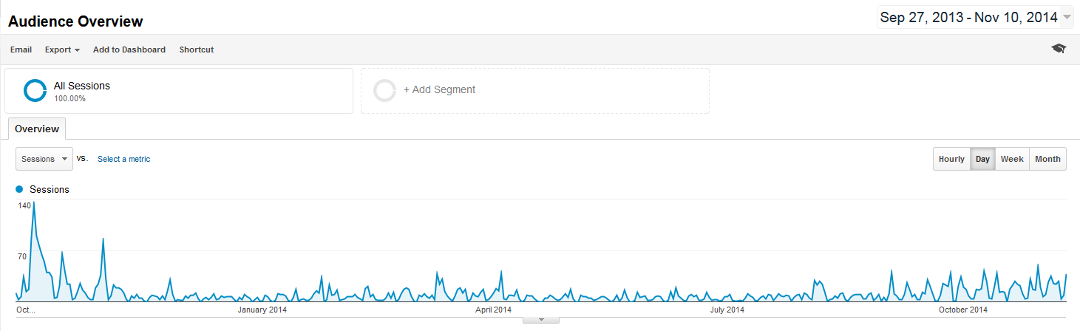

Sessions from the last board meeting to today
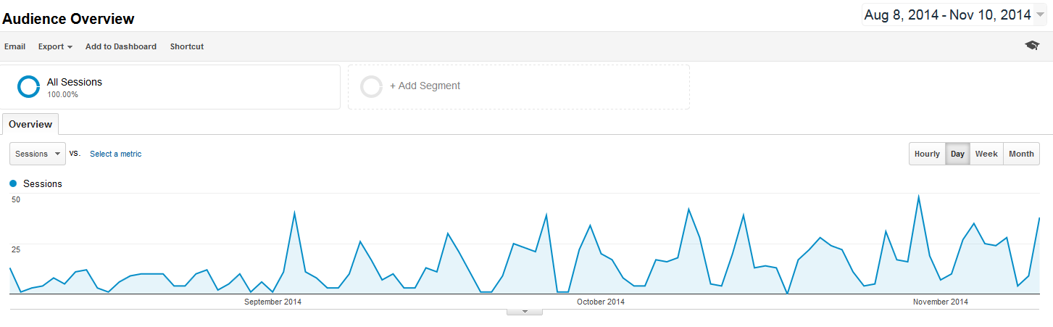

Page usage from August 8, 2014 to November 11, 2014. Conference pages are the most popular.
