HSLI Website report
Submitted by Stacey Knight-Davis
June 1, 2015, update June 16
This report requires no board action
As suggested at our last meeting, I have added the term of office to the officer listing on the website. I have also added a new page listing all officers and terms of office that I could extract from the HSLI Newsletter.
Sessions from November 12, 2014 to June 1, 2015
The spike in sessions in May is from newsletter postings. Sessions is roughly equivalent to the number of people visiting the site.
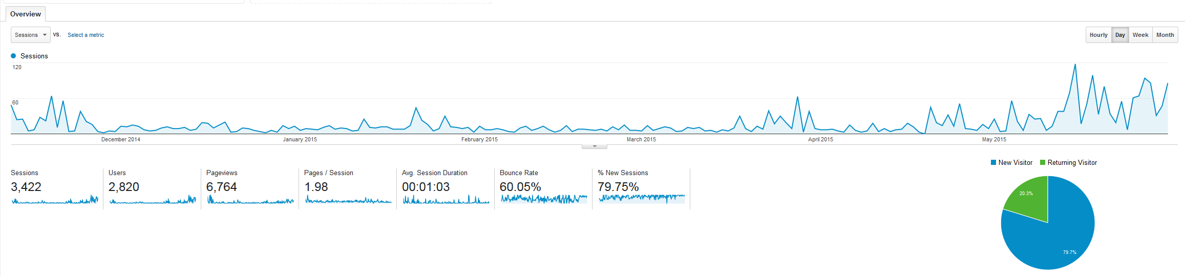
Pageviews, November 12 2014 to June 1, 2015
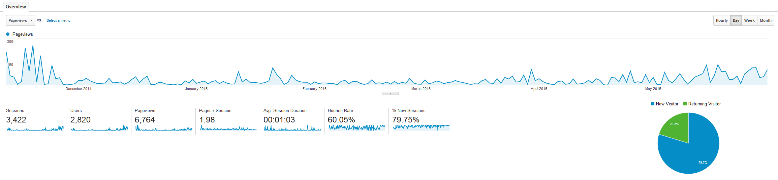
Pageview spike ends shortly after the conference. A pageview is counted each time a page is loaded in the browser.

The Newsletter and conference pages continue to be the most heavily used pages. The Directory is the next most heavily used page.

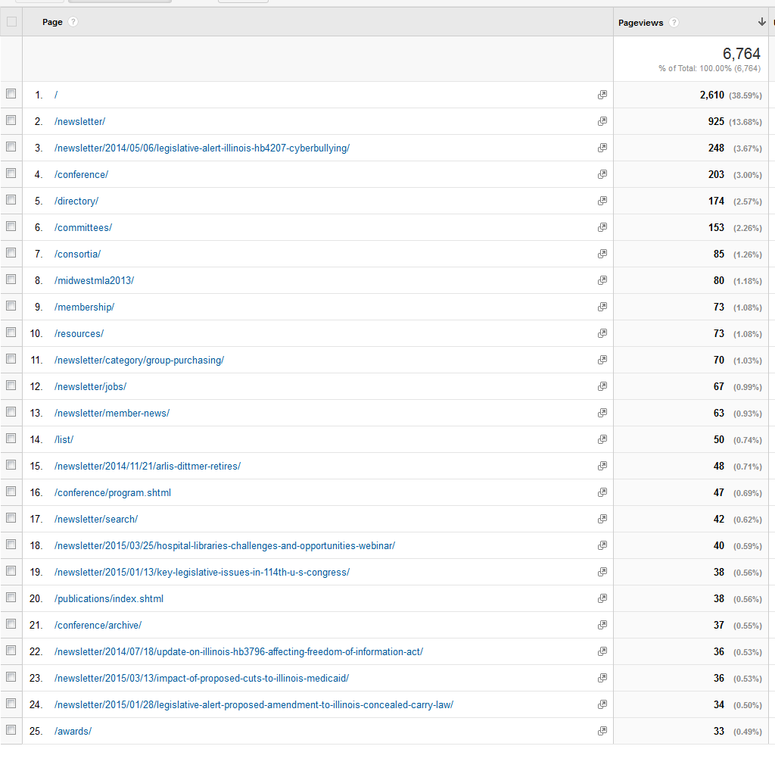

Facebook Page
The HSLI Facebook page now has 64 fans. Thanks to Eric Edwards for inviting several new fans.
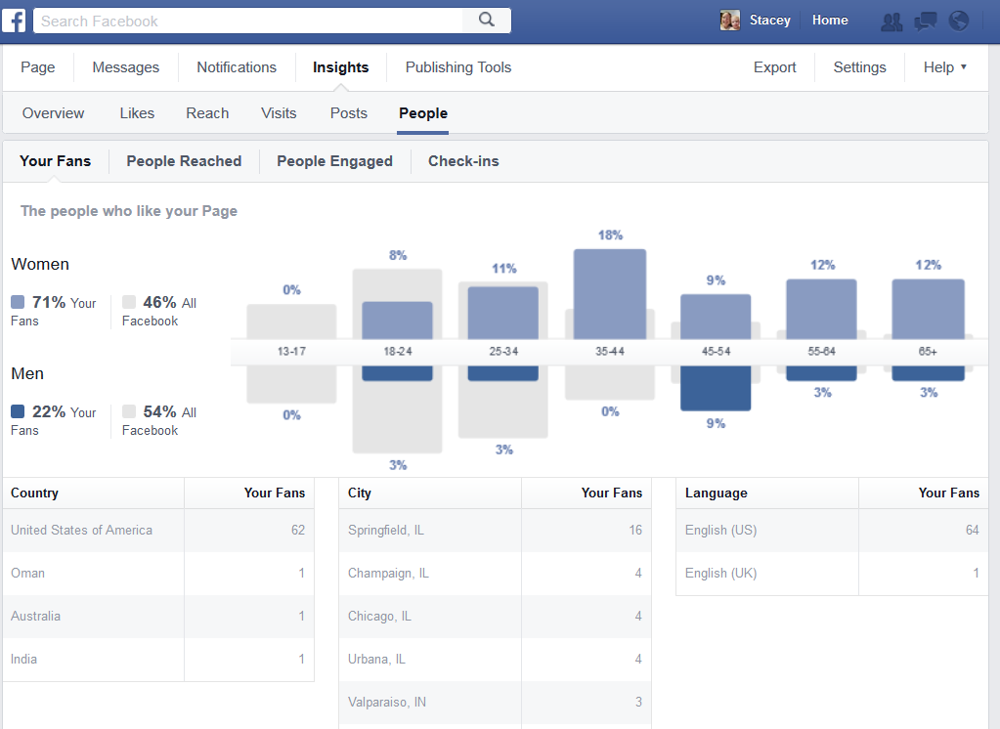
Popular posts, May 2015
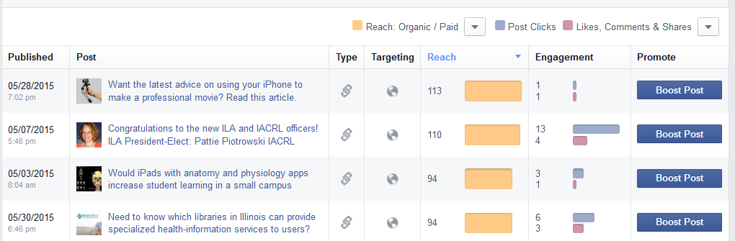

The most heavily shared post of 2014 was the conference photos album
