HSLI Listserv Committee Report
Submitted by Linda Feinberg
November 9, 2016
HSLI Listserv Postings by year
- Committee Member: Linda Feinberg
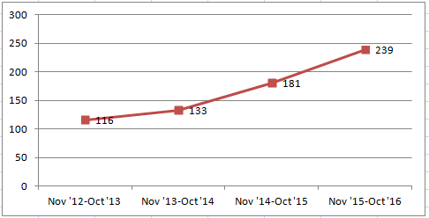
- Current HSLI Listserv:
  - HSLI list subscribers – 116
  - Postings: May 2016 – October 2016 - 143
  - See chart below for monthly postings
  - See chart below by broad subjects
- Current HSLIBoard Listserv:
  - HSLIBoard subscribers – 12
  - Postings: May 2016 – October 2016 - 58
  - See chart below for monthly postings
- New: Listserv addresses
  - Due to the transfer of the GMR from UIC to University of Iowa, on May 5th our list became hosted by the new GMR office at UIowa. Our contact at UI is Darlene Kaskie, Technology and Communication Librarian for the GMR
  - New HSLI listserv address: GMR-HSLI@list.uiowa.edu
  - New HSLI Board listerv address: GMR-HSLIboard@list.uiowa.edu
- Ongoing:
  - Updated e-mail address changes
  - Will continue to work with Membership to add new members and delete members who haven’t renewed for 2 years
  - Continue to investigate bouncing addresses (due to retiring, changed e-mail, etc)
  - Work on problems arrising from the ownership change and different settings

-

