HSLI Listserv Committee Report
Submitted by Linda Feinberg
October 25, 2017
HSLI Listserv Postings by year
- Committee: Linda Feinberg
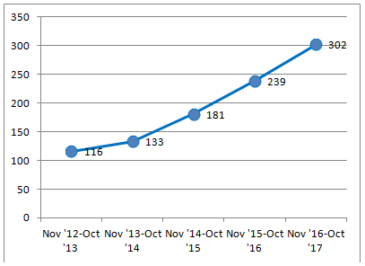
- Current HSLI Listserv:
  - HSLI list subscribers – 109
  - Postings: Nov 2016 – Oct 2017 - 302
  - See chart below for monthly postings
  - See chart below by broad subjects
  - See chart to right showing yearly totals
- Current HSLIBoard Listserv:
  - HSLIBoard subscribers – 15
  - Postings: Nov 2016 – Oct 2017 - 124
  - See chart below for monthly postings
- Ongoing:
  - Updated e-mail address changes
  - Will continue to work with Membership to add new members and delete members who haven’t renewed for 2 years
  - Continue to investigate bouncing addresses (due to retiring, changed e-mail, etc)

