HSLI Website report
Submitted by Stacey Knight-Davis
October 13, 2015
This report requires no board action
As suggested at our last meeting, I have added the term of office to the officer listing on the website. I have also added a new page listing all officers and terms of office that I could extract from the HSLI Newsletter.
Sessions from June 1, 2015 to October 12, 2015
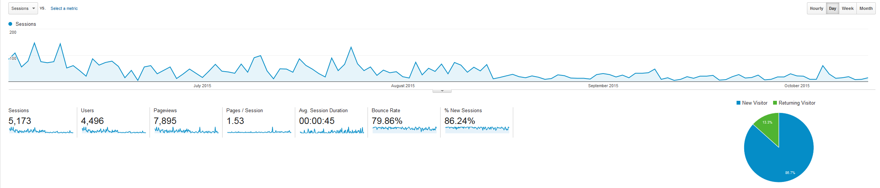
Pageviews, October 12, 2015
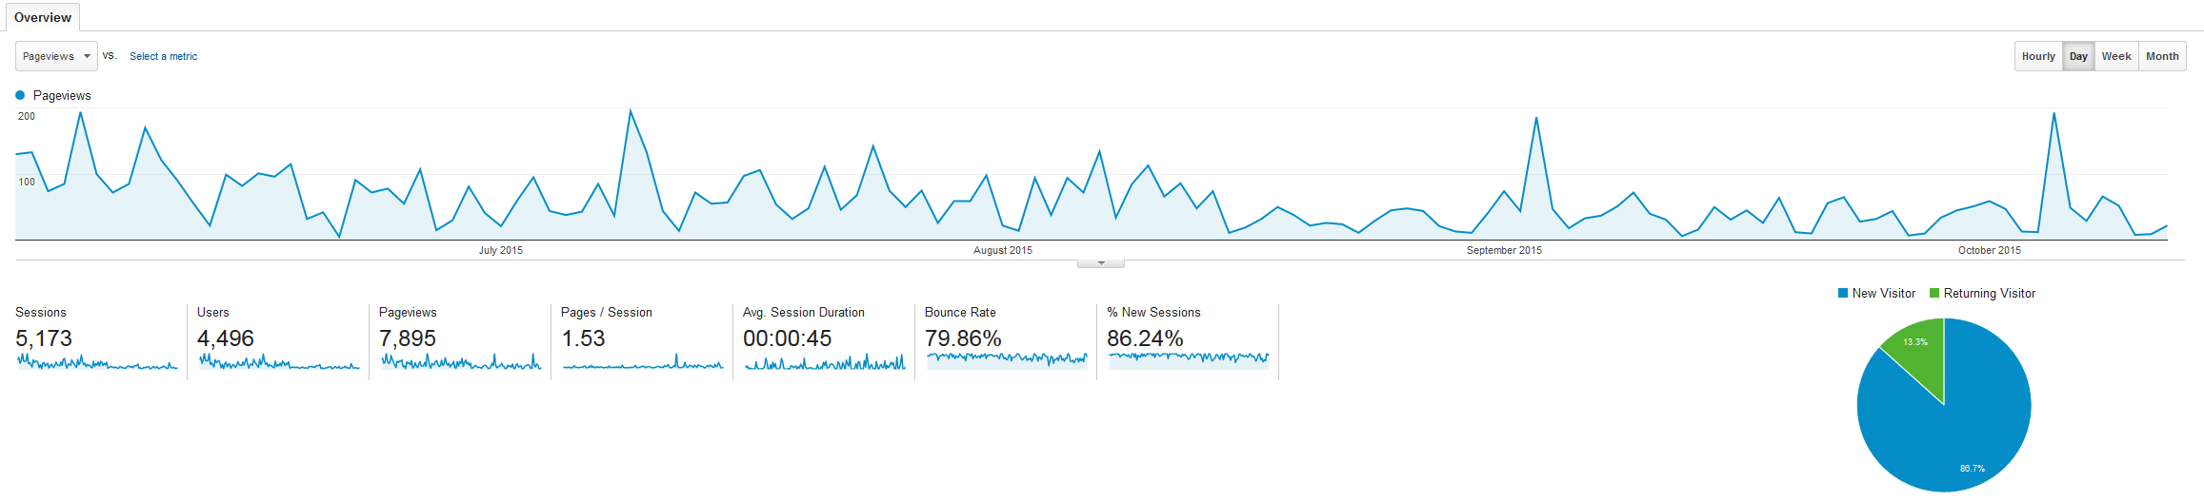

The Newsletter and conference pages continue to be the most heavily used pages. The Directory is the next most heavily used page.
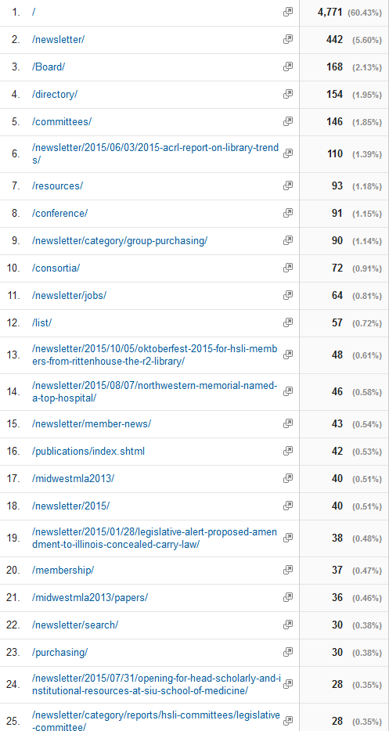

Facebook Page
The HSLI Facebook page has 73 fans.
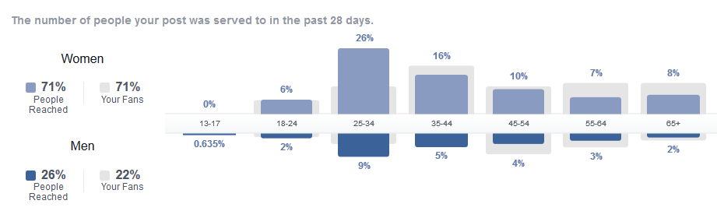
Popular posts
