HSLI Website report
Submitted by Stacey Knight-Davis
November 8, 2016
This report requires no board action

On 8/2/2016 a new Memorial page was added to the website. This page runs from Wordpress. Roy and I worked on the design. The URL is http://hsli.org/memorial/

Sessions, June 15, 2016 to November 7, 2016

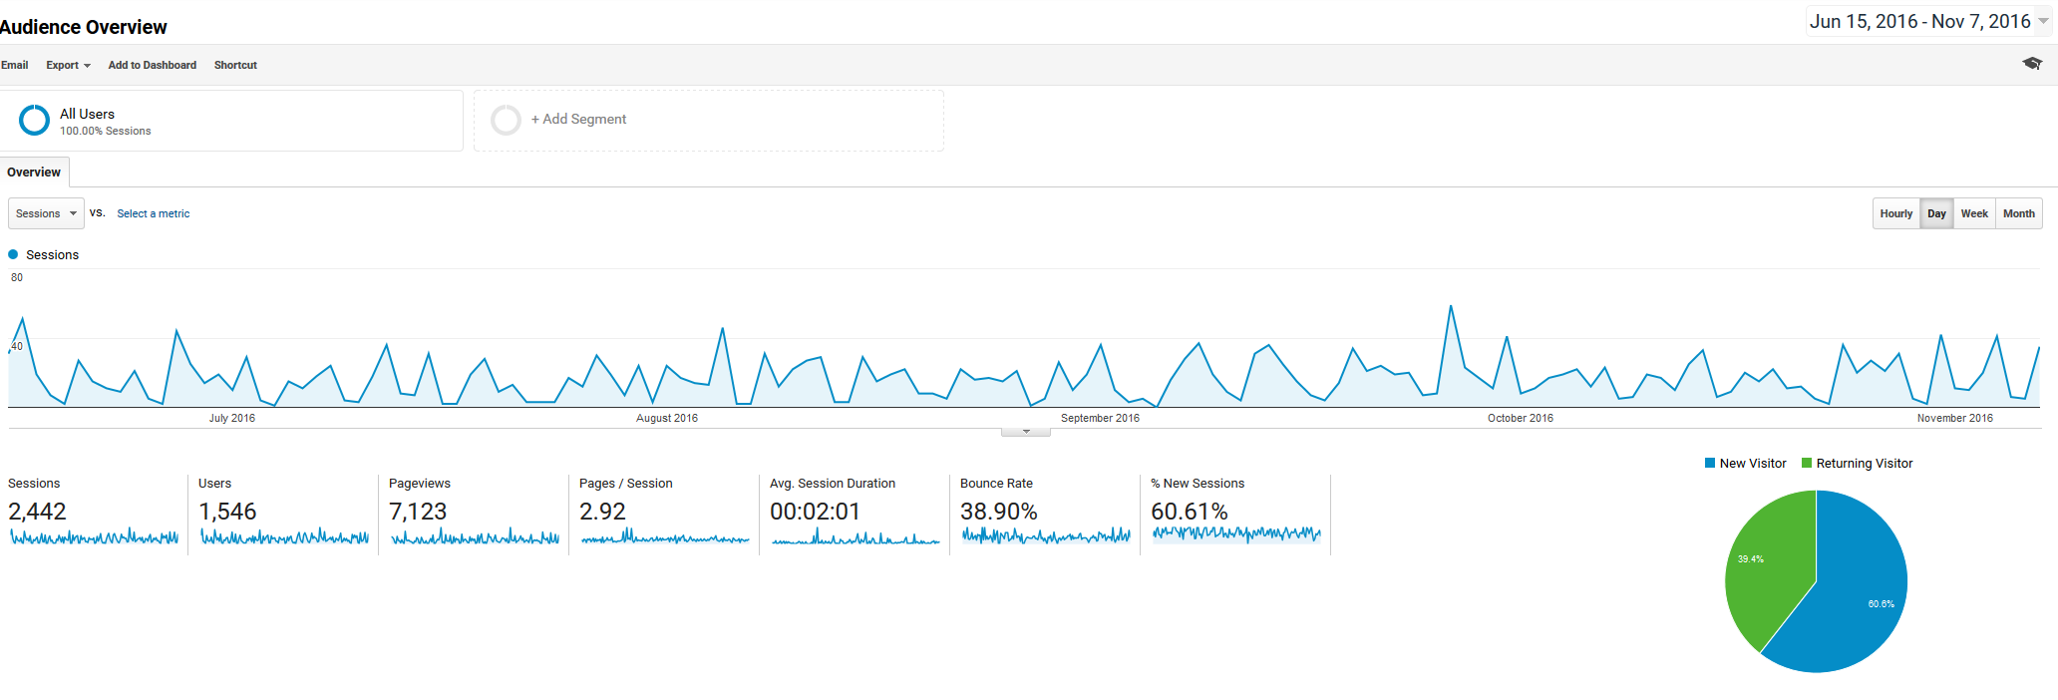

Website page views

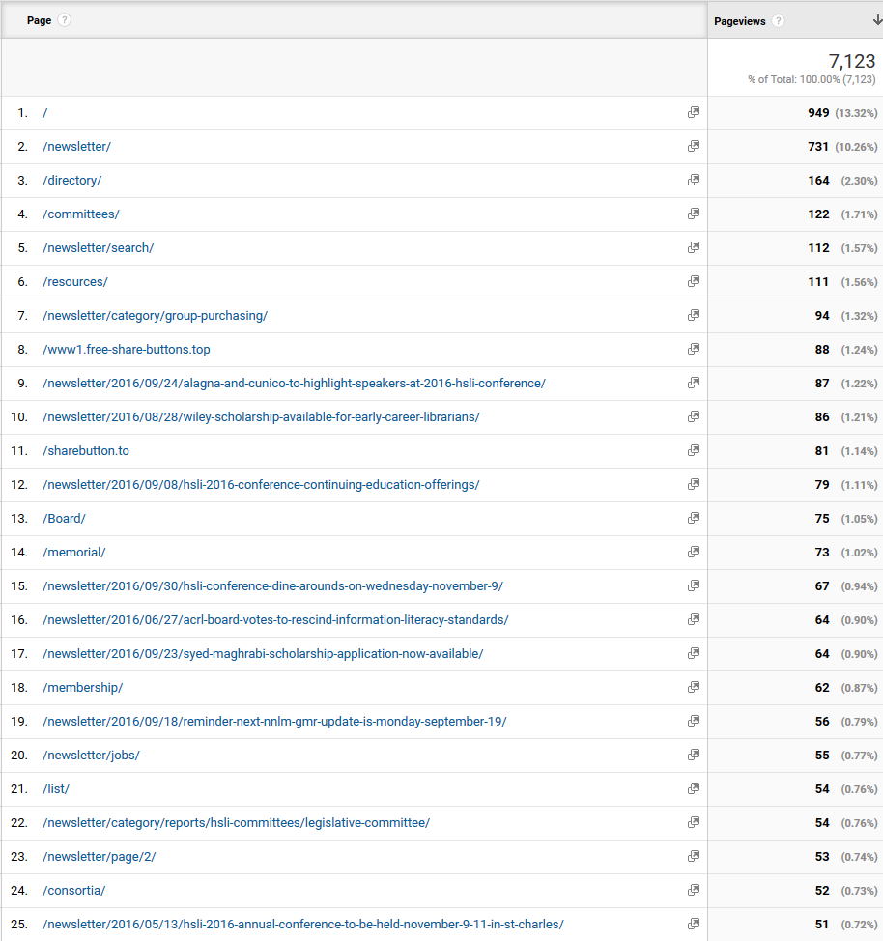

Facebook views

