HSLI Website report
Submitted by Stacey Knight-Davis
June 15, 2016
This report requires no board action
The 2016 conference page is up. It uses a responsive template, so it displays well on phones and desktop computers.
Sessions from October 22, 2015 to June 15, 2016
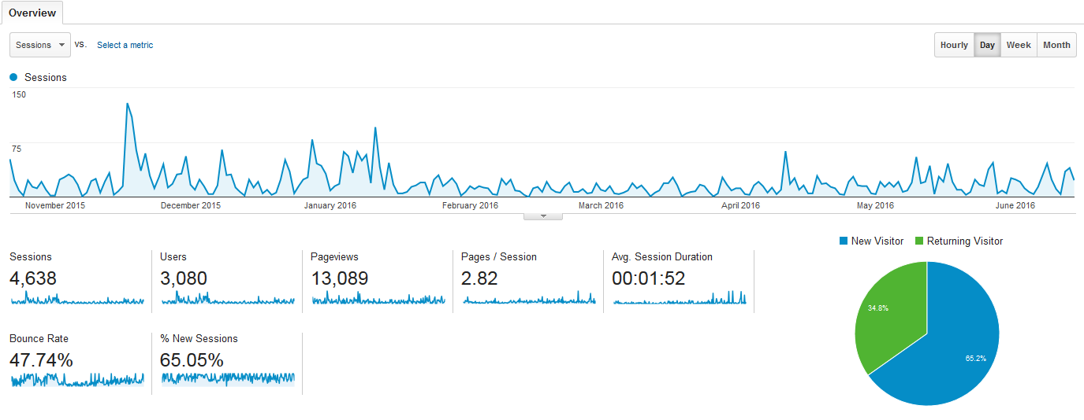

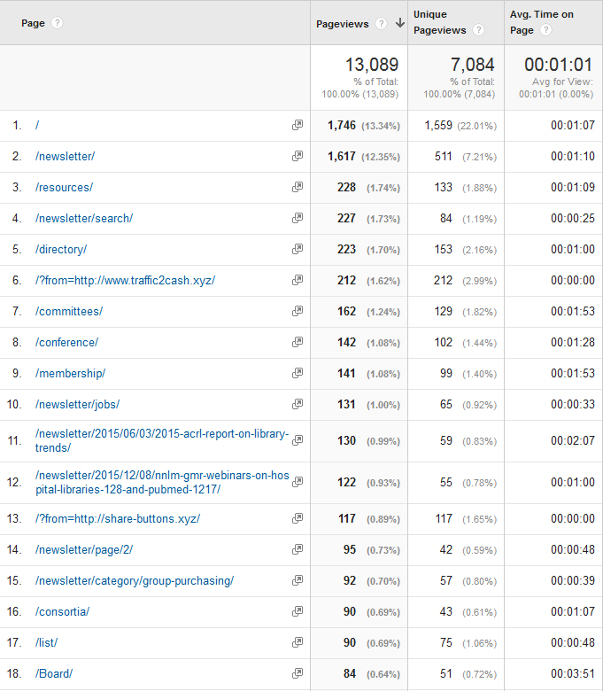

Top Facebook posts, March-June 2016

